

Specification

for

Foree Insaaf

Prepared by Muhammad Taimoor khan (2012124)

Rafay Imtiaz (1912162)

Supervised by: Dr Imran Amin

Table of Contents

Table of Contents ii

Revision History ii

SRS(Software requirement specific)

1. Introduction 8

1.1 Purpose 8

1.2 Document Conventions 8

1.3 Intended Audience and Reading Suggestions 8

1.4 Product Scope 8

1.5 References 8

2. Overall Description 9

2.1 Product Perspective 9

2.2 Product Functions 9

2.3 User Classes and Characteristics 9

2.4 Operating Environment 9

2.5 Design and Implementation Constraints 9

2.6 User Documentation 10

2.7 Assumptions and Dependencies 10

3. External Interface Requirements 10

3.1 User Interfaces 10

3.2 Hardware Interfaces 10

3.3 Software Interfaces 10

3.4 Communications Interfaces 10

4. System Features 11

4.1 Registration 11

4.2 Login 11

4.3 Search facility 11

4.4 Select lawyer/Legal service 11

4.5 Communications 12

5. Other Nonfunctional Requirements 13

5.1 Performance Requirements 13

5.2 Safety Requirements 13

5.3 Security Requirements 13

5.4 Software Quality Attributes 13

5.5 Business Rules 13

SDS (Software design specific)

1. Introduction 15

1.1 Purpose of this document 15

1.2 Scope of the document project 15

1.3 Definations acronyms and abbreviations 15

1.4 Reference 16

1.5 Overview of the document 16

2. System archietecture design 16

2.1 Section overview 17

2.2 program structure 17

2.3 Alternative considered 17

3. Design description of components 17

3.1 Section overview 17

3.2 Component and detail 18

4. User interface design 20

4.1 Section overview 20

4.2 Interface design rules 20

4.3 GUI components 20

5. Appendix : Glossary 26

6. User manual 39

Revision History

|  |  |  |  |
| --- | --- | --- | --- |
| **Name** | **Date** | **Reason For Changes** | **Version** |
|  |  |  |  |
|  |  |  |  |

Project Proposal

# Introduction

In an era of technology developments and digital change, the legal industry is prepared for a paradigm shift. I am thrilled to offer a forward-thinking project that works to reimagine how legal services are accessible, delivered, and experienced. Our proposal proposes the creation of an innovative online platform designed specifically for legal practitioners and clients seeking legal advice.

# Objective

To build an online platform that connects clients with qualified lawyers while also streamlining legal service access, increasing lawyer visibility, and fostering transparent, efficient, and secure interactions."

# Problem Description

Project uses a cutting-edge internet platform to address issues in the traditional legal industry. Currently, this industry struggles with difficulties like a shortage of qualified lawyers, lengthy methods, a lack of trust, and inefficient communication. My platform will provides faster access to lawyers, effective case management, more transparency, and in-the-moment communication to address issues. By doing this, you hope to completely transform the field of legal services by giving both clients and professionals correct representation, efficient procedures, and successful results.

# Methodology

Legal professionals register by giving contact information, then log in to access platform features. After logging in, users build detailed profiles that point out their practice areas, areas of expertise, credentials, and portfolio highlights. Lawyers investigate job postings submitted by clients and evaluate how well they match their skill set. They submit service proposals that include descriptions of methods, deadlines, and costs. Through the platform's messaging feature, clients can be contacted, allowing for thorough case discussions. Lawyers collaborate on projects and communicate updates through the messaging system. Through the site, finished projects are submitted, and safe payments are made. Customers provide reviews and ratings, which influence the reputation of lawyers on the platform. Lawyers can create invoices for clients who get platform-generated invoices for payment requests. Mutual feedback following project completion improves the reputation of the platform as a whole.

# Features

# User registration and login

# Profile setup

# Case Categories

# Client and layer communication

# Payment half pay/ full pay

# Hire Legal Advisor

# Invoicing and billing via email

# Reviews and ratings

# Additional Features

# Physical office visit appointment

# Reminder of physical office visit via email

# Documents and Image uploading

# Voice message

# Project Scope

The goal of this project is to create and build an online platform for linking clients with lawyers, expediting legal service access, and promoting effective communication. However, it is necessary to distinguish certain aspects of design, development, and research that are outside the scope of this project

# Feasibility Study

**Risks Involved**: An active internet connection is required. If data is not entered correctly, it will produce erroneous results. If the server is down, it may take some time to load. If the server is down, it may take some time to load. Human engagement is limited by the system.

**Resource Requirement**: In order to use this application, the user must have a computer running Windows, Mac OS X, Linux, or Unix, as well as a mobile device with him and access to the internet. We require a standard-spec computer or mobile device that runs Android or iOS. Internet connection.

# Solution Application Areas

my platform streamlines the legal services industry by connecting clients with qualified lawyers, addressing inefficiencies and challenges faced by clients and lawyers. It caters to various practice areas, including corporate, criminal, family, and immigration law.

1. Tools/Technology

**• Hardware Requirements:**

o Processor: 2 GHz or faster

o Hard Drive: 32 GB minimum, Recommended 64GB and beyond

o Memory: 8GB or more Internet connection with a 4 Mbps or higher

speed.

o Internet device

**• Software requirement:**

o Visual studio code is used to write PHP programs

o MySQL database is using to manage backend data

o CSS, HTML and Java Script to build the website front end

10. Expertise of the Team Members

* Are our project's execution is in my hands because I oversee the design, data, and development components. With a design background, I prioritize an engaging user interface, while my expertise in data administration enables seamless information retrieval. I provide cohesiveness and alignment in our approach by supervising all stages of development. I adhere to industry standards, ensuring our platform is created to flourish, under the supervision of sir Waqar Ahmed , an esteemed project adviser.

11. Milestones  
 User Interface Design

* Platform Access and Authentication
* Job Posting and Proposal System
* Configuration of Secure Communication
* Database Architecture
* Deployment and Hosting

# 12. Project Schedule

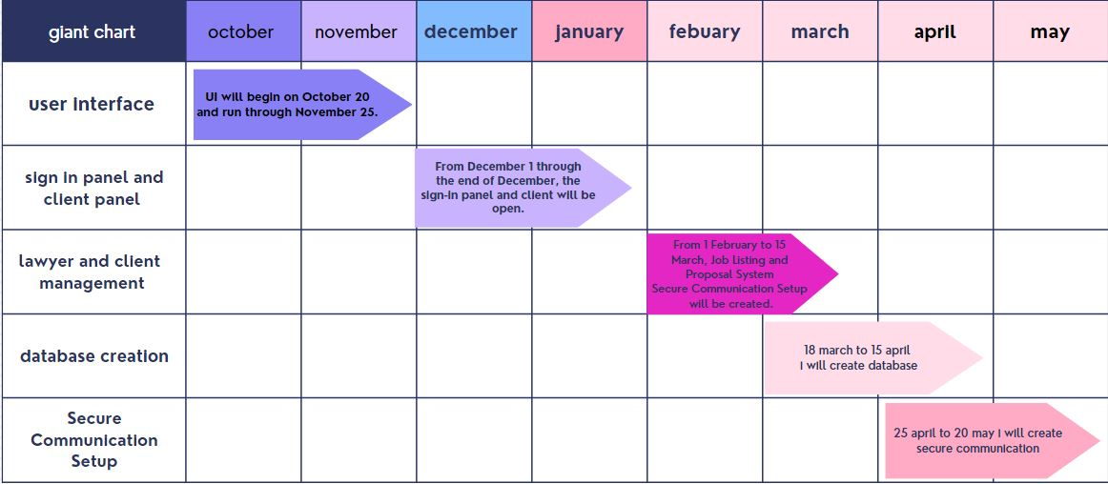

13. Work Breakdown Structure   
  
  
FYP 1

|  |  |  |
| --- | --- | --- |
| PHASES | TASKS | FYP-I |
| PHASES1 | TASKS1 | User interface |
| PHASES2 | TASKS2 | Sign-in panel and registration |
| PHASES3 | TASKS3 | Lawyer and client management |

# FYP 2

|  |  |  |
| --- | --- | --- |
| PHASES | TASKS | FYP-2 |
| PHASES1 | TASKS1 | DATABASE |
| PHASES2 | TASKS2 | SECURE COMMUNICATION |
| PHASES3 | TASKS3 | FEEDBACK REVIEWS |

SRS(System requirement specification)

# Introduction

## Purpose

The goal of this Software Requirements Specification (SRS) is to thoroughly detail the requirements of the "Foree Insaaf" platform, which attempts to bridge the gap between legal experts and clients in need of legal services. This SRS describes the exact features and functionalities needed to build the online platform.

## Document Conventions

This document complies to the latest industry standards for documentation. Using Microsoft Word, it is formatted in the "Times New Roman" font style. Headings are set at a fixed font size of 20 points, subheadings at 16 points, and main text at 12 points. To facilitate navigation, headings and subheadings are highlighted in bold.  
Intended Audience and Reading Suggestions

## Product Scope

<Provide a short description of the software being specified and its purpose, including relevant benefits, objectives, and goals. Relate the software to corporate goals or business strategies. If a separate vision and scope document is available, refer to it rather than duplicating its contents here.>

## References

<List any other documents or Web addresses to which this SRS refers. These may include user interface style guides, contracts, standards, system requirements specifications, use case documents, or a vision and scope document. Provide enough information so that the reader could access a copy of each reference, including title, author, version number, date, and source or location.>

# Overall Description

## Product Perspective

<Describe the context and origin of the product being specified in this SRS. For example, state whether this product is a follow-on member of a product family, a replacement for certain existing systems, or a new, self-contained product. If the SRS defines a component of a larger system, relate the requirements of the larger system to the functionality of this software and identify interfaces between the two. A simple diagram that shows the major components of the overall system, subsystem interconnections, and external interfaces can be helpful.>

## Product Functions

(Foree Insaaf)The primary function of the "Foree Insaaf" platform is to offer a seamless means for clients to connect with legal professionals, enabling access to legal advice and services.  
When a client seeks legal assistance and reserves a lawyer's services, the system generates a unique identifier known as a "Legal Token."  
The Legal Token serves as a key component of the booking process, providing a reference for the legal service reservation.  
Token Generation: The system generates a booking summary that incorporates the Legal Token for the reserved legal service.  
Key features of the "Foree Insaaf" platform include:Legal Professional Directory: The platform provides a comprehensive listing of available lawyers and legal services, allowing clients to browse, compare, and select professionals based on their specific legal requirements.

## User Classes and Characteristics

<Identify the various user classes that you anticipate will use this product. User classes may be differentiated based on frequency of use, subset of product functions used, technical expertise, security or privilege levels, educational level, or experience. Describe the pertinent characteristics of each user class. Certain requirements may pertain only to certain user classes. Distinguish the most important user classes for this product from those who are less important to satisfy.>

## Operating Environment

"Foree Insaaf" is a web-based application that may be accessed by a wide range of people. It is platform-independent and can run on a variety of operating systems. Interaction requires only a device with a keyboard and mouse. The technology generates time-limited tokens that demand the user's physical presence for legal consultations.

## Design and Implementation Constraints

The platform is interoperable with a variety of operating systems, making it accessible to a wide range of users. To enter data into the system's interface, a conventional keyboard and mouse are required. Tokens are generated and have a set validity period, during which users must visit the chosen legal professional.

## User Documentation

To assist users in properly using the "Foree Insaaf" platform, user documentation in the form of a client's manual will be given. The documentation will be written in simple language, simplifying user interactions with the system but hiding its inherent complexity.

## Assumptions and Dependencies

The platform is not restricted by operating systems, ensuring a broad reach. For user interaction, basic input equipment such as a keyboard and mouse are required. Tokens have particular validity periods, during which users are supposed to consult legal specialists.

# External Interface Requirements

## User Interfaces

To ensure a seamless experience for customers and legal professionals, the "Foree Insaaf" platform prioritizes intuitive and user-friendly interfaces. These interfaces are intended to be available via ordinary web browsers and mobile devices, improving platform usability.

.

## Hardware Interfaces

Users of the system must have a device that runs a browser and complies with the system's minimal requirements. The gadget must be capable of entering text and navigating websites. The apparatus must meet the enumerated minimum requirements:

1. One GHz CPU

2. 512 MB of RAM

3. One GB of internal storage

## Software Interfaces

<Describe the connections between this product and other specific software components (name and version), including databases, operating systems, tools, libraries, and integrated commercial components. Identify the data items or messages coming into the system and going out and describe the purpose of each. Describe the services needed and the nature of communications. Refer to documents that describe detailed application programming interface protocols. Identify data that will be shared across software components. If the data sharing mechanism must be implemented in a specific way (for example, use of a global data area in a multitasking operating system), specify this as an implementation constraint.>

## Communications Interfaces

An email notification will be sent to the guest's account when a specific reservation is made at the

same time. clients will be informed during check-in A reliable internet connection is necessary for

that capability to be realized. The client's computer will be connected to an international band in most cases to deliver the efficient service.

# System Features

"Foree Insaaf" addresses the legal industry's problem of no-show clients by delivering efficient scheduling, real-time availability updates, and dynamic reservations. Reminders are sent to clients, legal experts' availability is updated, and the system optimises resource allocation, avoiding wasted time and missed opportunities.

## Registration

4.1.1 Description and Priority

Both users and administrators must register initially to access their profiles.

Priority level: High.

4.1.2 Stimulus/Response Sequences

Users and admins register by providing necessary information. Registration ensures authenticity. Priority email communication for updates.

Lawyer register for profile updates. Users can check if a lawyer is available or not.

Registration enables user-lawyer connections.

4.1.3 Functional Requirements

Registration is necessary for user and lawyer details. Registration verifies the authenticity of lawyers. Users and lawyers can connect through the registration process.

## Login

4.2.1 Description and Priority

Applies to the system administration module. Users must input a valid username and password for platform access.

Priority level: High.

4.2.2 Stimulus/Response Sequences

Users select the login option. The system presents the login page.

After entering credentials, users press "login”. The system verifies user identity.

Successful authentication leads to platform access.

4.2.3 Functional Requirements

Users must log in with valid credentials. The system employs secure login measures for user protection.

## Search Facility

4.3.1 Description and Priority

Allows users to search for legal services using various criteria.

Priority level: High.

4.3.2 Stimulus/Response Sequences

Users select the search field.

Any legal service can be searched.

The search filter assists in finding specific legal services.

Users choose the "search" button.

The system displays a list of available lawyers and legal services based on criteria.

4.3.3 Functional Requirements

Users conduct searches or use the filter to display relevant results.

## Select Lawyer/Legal Service

4.4.1 Description and Priority

A Users select a lawyer or legal service to view more information.

Priority level: High.

4.4.2 Stimulus/Response Sequences

Users choose a lawyer or legal service to access additional information.

Users can view the lawyer's profile and legal service details.

Users select a legal service, which generates a token.

Users confirm the legal service and time.

Users receive a confirmation message or decline.

4.4.3 Functional Requirements

Users can view lawyer profiles, legal service details, and generate tokens for legal services.

Users receive confirmation messages or declines for selected legal services.

## Communication

4.5.1 Description and Priority

Enables real-time communication between users and lawyers/legal services.

Priority level: High.

4.5.2 Stimulus/Response Sequences

Users can initiate communication with lawyers/legal services via the platform's messaging system. Users discuss case details and requirements with lawyers/legal services.

Communication takes place in real time, ensuring timely responses and updates.

4.5.3 Functional Requirements

Users and lawyers/legal services can communicate seamlessly through the platform.

Real-time communication facilitates clear and efficient case discussions and updates.

This revised section highlights the core functionalities of "Foree Insaaf," emphasizing registration, login, search, lawyer/legal service selection, and real-time communication between users and lawyers/legal services.

## Login

4.6.1 Description and Priority

Applies to the system administration module. Users must input a valid username and password for platform access.

Priority level: High.

4.6.2 Stimulus/Response Sequences

Users select the login option. The system presents the login page.

After entering credentials, users press "login”. The system verifies user identity.

Successful authentication leads to platform access.

4.6.3 Functional Requirements

Users must log in with valid credentials. The system employs secure login measures for user protection.

# Other Nonfunctional Requirements

## Performance Requirements

System response times should meet performance standards.

Loading time for user interface screens must not exceed two seconds for quick access to features.

User login confirmation should occur within five seconds for system efficiency.

Search results must be returned in less than five seconds to ensure a prompt search function.

## Safety Requirements

The system features various user tiers with secure access using a username and password.

Backups will be maintained to ensure the security of the system database.

The system can be repaired in case of emergencies.

## Security Requirements

Access to different subsystems will be determined by user roles, including owner, managers, and customer care agents.

A user login screen requesting a username and password will control access to the various subsystems.

## Software Quality Attributes

The system will be accessible during regular business hours.

* Correctness: The system should adhere to requirements and meet user objectives.
* Efficiency: The system should complete tasks with fewer resources and in less time.
* Flexibility: The system should allow for the addition of new features and efficient management.
* Integrity: Data security and referential integrity in database tables and interfaces.
* Maintainability: The system should be easily maintainable and adaptable to adjustments.
* Reliability: The system should meet reliability requirements in terms of time between failures and time to recovery.
* Reusability: Components of the system should be reusable in other contexts.
* Testability: The system should be testable to confirm proper functioning.
* Usability: The system should be user-friendly and easy to use.
* Robustness: The system should execute operations accurately without encountering unforeseen faults.
* Portability: The system should be portable and work in various Microsoft Windows environments.

These nonfunctional requirements ensure that "Foree Insaaf" performs efficiently, maintains security, and meets quality standards.

## Business Rules

* Users and legal professionals must register with valid information.
* A unique token is generated for booked legal services.
* Display available lawyers and legal services.
* Lawyers' profiles must be comprehensive.
* Real-time communication between clients and lawyers is facilitated.
* Collaboration on projects is allowed.
* Secure payments are processed through the platform.
* Client reviews and ratings influence lawyer reputation.
* Invoices can be created for payment requests.

# Other Requirements

A few sessions will be needed to explain the system's capabilities to users before it is finished

developing and delivered to the client, as well as some time for users to become accustomed to the system. Following those sessions, it is necessary for a member of the development team to spend some time working in the system's background for a predetermined amount of time. During that time, any new bugs that were not discovered during previous stages of the development process will be found. To get reservation email notifications, a client's email account must be active.

SDS(Software Design Specification)

The Software Design Specification (SDS) sections provide you with guidelines related to the structure and the contents of SDS document. The Software Design Specification document includes at least these sections.

For the project, your team may have good reasons for wanting to deviate from this proposed outline. If a section is not applicable in your case, do not delete it; instead, give the topic heading and write "Not applicable".

You will note that there is some overlap in the content between different documents (i.e., the User Requirements Specification Document and the Software Design Specification Document.) This redundancy allows each document to stand on its own.

**The Software Design Specification Outline**

**1. Introduction**

**1.1 Purpose of this document**

This document outlines the specifications for the development of Foree Insaaf, providing a comprehensive overview of the features, functionalities, and technical requirements.

**1.2 Scope of the development project**

Foree Insaaf aims to streamline the hiring process for legal advisors, providing a secure and user-friendly platform for clients and lawyers.

**1.3 Definitions, acronyms, and abbreviations**

Foree Insaaf:

Definition: The project name, representing a lawyer and client freelance platform.

User:

Definition: An individual who interacts with the "Foree Insaaf" platform, either as a client seeking legal services or as a lawyer providing legal services.

Job Posting:

Definition: The process where clients publish requests for legal services on the platform.

Messaging System:

Definition: The feature that enables real-time communication between clients and lawyers on the platform.

Payment Integration:

Definition: The functionality allowing users to make secure payments for legal services provided through the platform.

Acronyms and Abbreviations

SDS:

Acronym: Software Design Specification.

UI:

Acronym: User Interface.

API:

Acronym: Application Programming Interface.

HTTPS:

Acronym: Hypertext Transfer Protocol Secure.

DB:

Abbreviation: Database.

UX:

Acronym: User Experience.

QA:

Acronym: Quality Assurance.

CPU:

Acronym: Central Processing Unit.

URL:

Abbreviation: Uniform Resource Locator.

SSL:

Acronym: Secure Sockets Layer.

HTML:

Acronym: Hypertext Markup Language.

**1.4 References**

This section will include technical books and documents related to design issues. Be certain that the references you give are complete and in the appropriate format.

**1.5 Overview of document**

Foree Insaaf" offers a detailed insight into the architecture and functionalities of the lawyer and client freelance platform. With a focus on system components, data flow, user interface, and security measures, the document caters to developers, stakeholders, testers, and project managers. The SDS encompasses an overview of the platform's purpose and scope, providing an accessible guide for understanding key aspects. Organized into sections, including system behavior, performance, error handling, and dependencies, it aims to facilitate efficient comprehension. The inclusion of a revision history ensures a transparent record of document updates over time.

**2. System architecture description**

* 1. **Section Overview**  
     The system architecture of "Foree Insaaf" is designed as a three-tier model, encompassing the presentation layer, application layer, and data layer. In the presentation layer, the user interacts with the platform through a responsive and intuitive web interface. The application layer hosts the core business logic, handling user requests, job postings, messaging, and payment processing. This layer ensures seamless communication between the presentation and data layers. The data layer comprises a well-structured database, including tables for users, jobs, messages, and payments. This architecture enhances scalability, maintainability, and performance, providing a robust foundation for the lawyer and client freelance platform's functionalities.
  2. **General Constraints**  
     "Foree Insaaf" software project encompass financial limitations, time constraints, and technological considerations. Budgetary constraints dictate the available resources, impacting development costs and infrastructure expenses. Time constraints set specific deadlines, influenced by market demands or regulatory requirements. Technological constraints involve limitations imposed by the chosen technology stack, encompassing compatibility issues and software dependencies. Regulatory and compliance constraints outline the necessary adherence to laws and industry standards. Scalability and performance constraints define the system's ability to handle growth and meet performance criteria. Security constraints mandate measures to ensure data confidentiality, integrity, and availability, aligning with legal and industry regulations. Resource constraints encompass limitations in human resources, skills, and expertise available for the project, influencing overall development strategies and planning. Managing these constraints is essential for effective project execution.
  3. **Program Structure**  
     uses a modular and well-organized architecture to promote clarity, maintainability, and efficiency. The codebase is separated into modules or components, each of which is responsible for a specific functionality, such as user administration, job posting, communications, and payment processing. These modules are integrated, encouraging code reuse and reducing dependencies. The programme structure follows industry best practices, with a clear separation of concerns, which isolates different components of the application, such as the user interface, business logic, and data access. This modular structure improves scalability, debugging, and collaborative development activities, resulting in a more robust and maintainable codebase.
  4. **Alternatives Considered**Several options were investigated to address specific design and implementation decisions. For example, several frameworks and libraries were assessed for the web application's frontend, taking into account characteristics such as usability, community support, and scalability. In addition, different database systems were evaluated for optimal data storage and retrieval performance. Several payment processing systems were investigated, with aspects such as transaction prices, security features, and ease of integration taking precedence. Each choice was carefully analysed against project criteria and objectives, which influenced the technologies and methodologies used in the creation of "Foree Insaaf." This careful assessment guarantees that the chosen solutions are consistent with the project's objectives and limits.

1. **Detailed description of components**  
     
   1. **Section Overview**  
      Critical components have been meticulously created to maximise platform functionality. The User Management Component is responsible for user registration, authentication, and profile management. The Job Posting Component manages the development, listing, and application processes for legal jobs. A strong Messaging System enables real-time contact between clients and lawyers, resulting in more efficient discussions. The Payment Integration Component secures financial transactions for legal services. A separate Data Storage and Management Component organises user profiles, employment information, and payment records. The Security Component implements access controls, encryption, and other safeguards to protect user data. These components work together to build a solid basis that ensures a consistent user experience, secure interactions, and efficient legal service management.
   2. **Component n Detail (include a sub-section for each component)**

Component n Detail (include a sub-section for each component)

A structured description usually works. For example, if your components are classes you

may wish to include the following subsections

3.2.1. Description:

"Foree Insaaf" is a platform that manages user registration, authentication, and profile management using private data members for secure storage of sensitive information. The platform's User Management Component ensures user registration and login processes, while the Job Posting Component manages legal job processes using public and private data members. The Messaging System Component enables real-time communication, while the Payment Integration Component focuses on secure financial transactions. The Data Storage and Management Component organizes databases with private and secure user, job, and payment data using methods like RetrieveUserData and StoreJobData. The Security Component ensures access controls and encryption, safeguarding user data across the platform.

3.2.2. Data Members (include type, visibility, and description)

In the User Management Component of "Foree Insaaf," the private data member, User Information, is an object type designed for storing sensitive user details like encrypted passwords and authentication tokens. This data member, with its private visibility, ensures that critical user credentials are accessible solely within the confines of the User Management Component, enhancing security. On the other hand, the public data member, User Profile, is of object type and holds non-sensitive user information such as usernames, emails, and profile preferences. With public visibility, this data member facilitates seamless interaction across different components, supporting user customization and a user-friendly experience on the platform.

3.2.3. Methods (include English or psuedocode descriptions for each one)

User-related functionalities are driven by fundamental methods within "Foree Insaaf's User Management Component." The RegisterUser method allows you to create a new user account by passing in parameters such as your username and password. Its pseudocode includes securely storing user information and creating an authentication token. AuthenticateUser validates user credentials during login by comparing inputted data to stored information and giving access after successful validation. UpdateUserProfile allows users to change their profile information, including the username and new information. This method pseudocode requires updating the database with the user's profile information. These approaches work together to provide a secure and user-friendly experience, including account creation, authentication, and profile customisation.

**SDS component template**

The template given below suggests a reasonable structure for giving a thorough description of each component described in Part 3 of the SDS. The specific information depends in part on the design approach.

|  |  |
| --- | --- |
| Identification | Foree insaaf |
| Type | A module, a subprogram, a data file, a control procedure, a class, etc |
| Purpose | The installation of a computer will significantly affect the system's performance even though the system was built to have the lowest possible system performance requirements. The loading time for user interface screens should not be longer than two seconds. Log-in information must be confirmed within five seconds for system efficiency.lawyers freelancing system will be accessible to the clients,lawyers , and customer care agents. Access to the various subsystems will be secured by a user log-in page that demands a user name and password. By maintaining backup systems, the security of the system database is guaranteed. |
| Function | In the "Foree Insaaf" platform, user engagement begins with the imperative step of user registration, granting access to a myriad of additional features. Upon registration, all user information is securely stored in the MySQL cloud database, ensuring data integrity and accessibility. Users, whether seeking legal services or providing them, experience a seamless journey with personalized outputs. For instance, if a user wishes to deliver legal documents, they receive comprehensive information and real-time tracking updates on the assigned legal professional. |
| Subordinates | The internal structure of the component, the constituents of the component, and  the functional requirements satisfied by each part |
| Dependencies | :"Foree Insaaf" relies on critical dependencies, including MySQL for data storage, a web framework for streamlined development, messaging APIs for real-time communication, payment gateways for secure transactions, encryption libraries(http) for data security, cloud services (e.g., AWS), and user authentication services for account security.  You can access the system regardless of the operating system you are running. You require a keyboard and mouse to enter data into the system's interface. The system creates a token, and is good for a limited time, during which the user must go to the restaurant  interface: In "Foree Insaaf," interfaces are essential for user engagement and system functionality. The User Interface (UI) provides an intuitive experience, enabling clients and lawyers to navigate, post jobs, and manage profiles seamlessly. API interfaces facilitate communication between software components, powering features like real-time messaging and secure payment processing. Database interfaces ensure efficient data storage and retrieval, maintaining the integrity of user information, job details, and transactions. These interfaces collectively form the linchpin of the platform, connecting users with functionalities and ensuring a responsive, user-friendly  experience on the "Foree Insaaf" legal freelance platform. |
| Interfaces | There must be text fields, drop-down menus, checkboxes, images, and buttons on the user interface. All menus must have buttons that let the user move about the system. Additionally, the system must have a calendar menu and a time slot menu, An email notification will be sent to the guest's account when a specific reservation is made at the same time. Guests will be informed during check-in A reliable internet connection is necessary for that capability to be realized. The client's computer will be connected to an international band in most cases to deliver the efficient service. |
| Resources | Simple resources include a laptop and some software, but in order to complete them, we first need bracket software for the user interface, followed by Visual Studio to create the database, which is MySQL, and then we must purchase a domain to launch our website. |
| Processing | :"Processing" in the context of "Foree Insaaf" is most likely referring to the platform's many computational and procedural processes required to execute its features. This comprises activities including user registration, job posting processing, messaging system operations, payment transaction processing, and data storage and retrieval procedures. Each of these processes is intended to deliver a pleasant and efficient user experience, allowing clients and lawyers to connect seamlessly while assuring the platform's security and reliability. The processing component includes a variety of actions that all work together to deliver the intended features and services on the "Foree Insaaf" platform. |
| Data | For the data internal to the component, describes the representation method, initial values, use, semantics, and format. This information will probably be recorded in the data dictionary. |

1. **User Interface Design**
   1. **Section Overview** The User Interface Design section focuses on creating an intuitive and visually appealing experience for "Foree Insaf" users. Emphasizing simplicity and functionality, this segment outlines the design principles governing user registration, login processes, and the overall dashboard. It delves into the presentation of comprehensive legal profiles, ensuring ease of navigation and efficient real-time messaging. The user interface aims to provide a seamless and user-friendly interaction, promoting accessibility and clarity throughout the platform.
   2. **Interface Design Rules**  
      We utilised straightforward HTML for the thesis, two different types of displays (flockbox and display inline), and CSS for colour management. We used the bootstrap framework, and there is a Java library called JQT
   3. **GUI Components**  
      integrates essential graphical user interface (GUI) components for a seamless user experience. Users engage through a user-friendly registration form, secure login interface, and a dynamic dashboard displaying available legal services. Detailed legal professional profiles, a robust search bar, and a real-time messaging system enhance accessibility. The platform incorporates a notification center, feedback, and rating system, along with a settings panel for user customization. A dedicated help and support section ensures user guidance. These components collectively contribute to an efficient, visually appealing, and intuitive interface for clients and legal professionals
   4. **Detailed Description**

This screenshot shows five icons.

1. They can go to homepage of our website
2. a restaurant's specialties if they want to visit the homepage of our website.
3. Restaurant that are popular in our website that will popup if they will choose popular restaurants
4. well-liked restaurants are displayed in our website gallery, and each restaurant's menu is available there.
5. Without logging in, users are unable to access any pages on your website.
6. people wish to sign up and use our website.

**HOME**

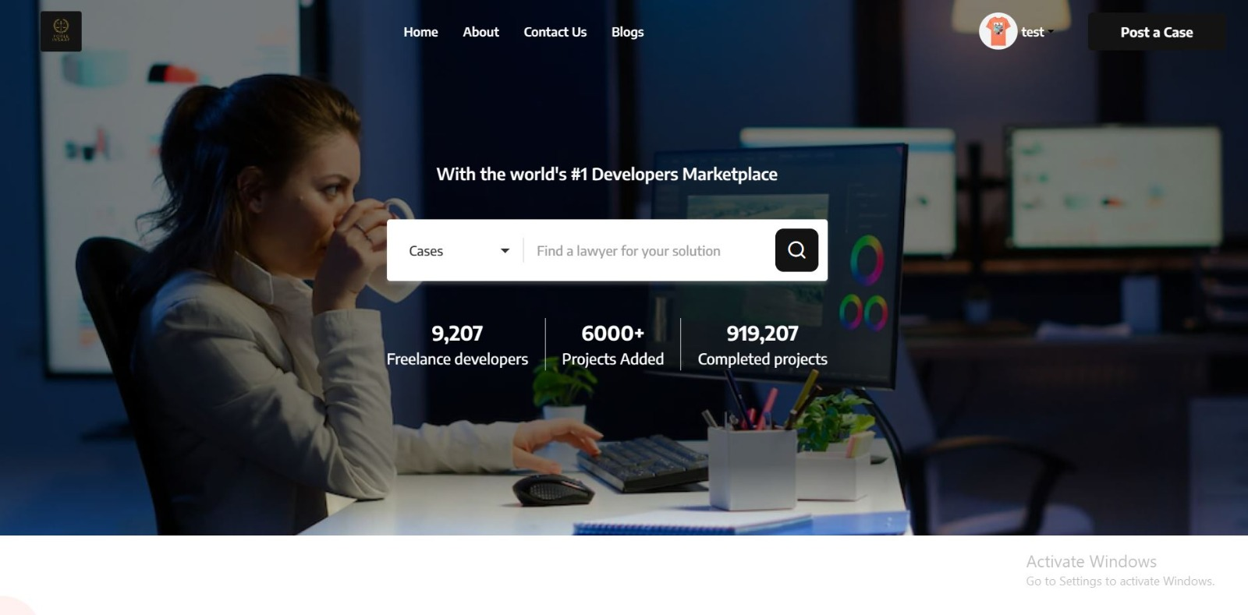

**Login page**

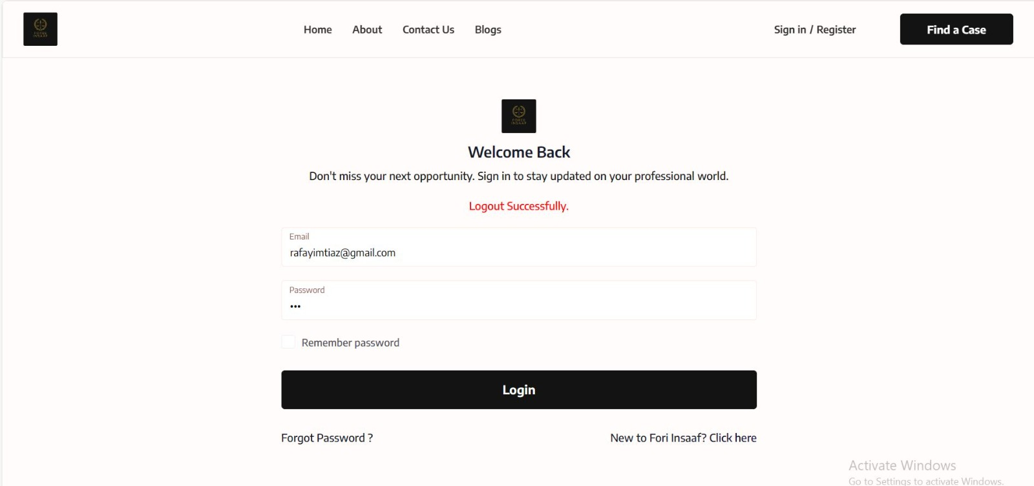

**Signup page**

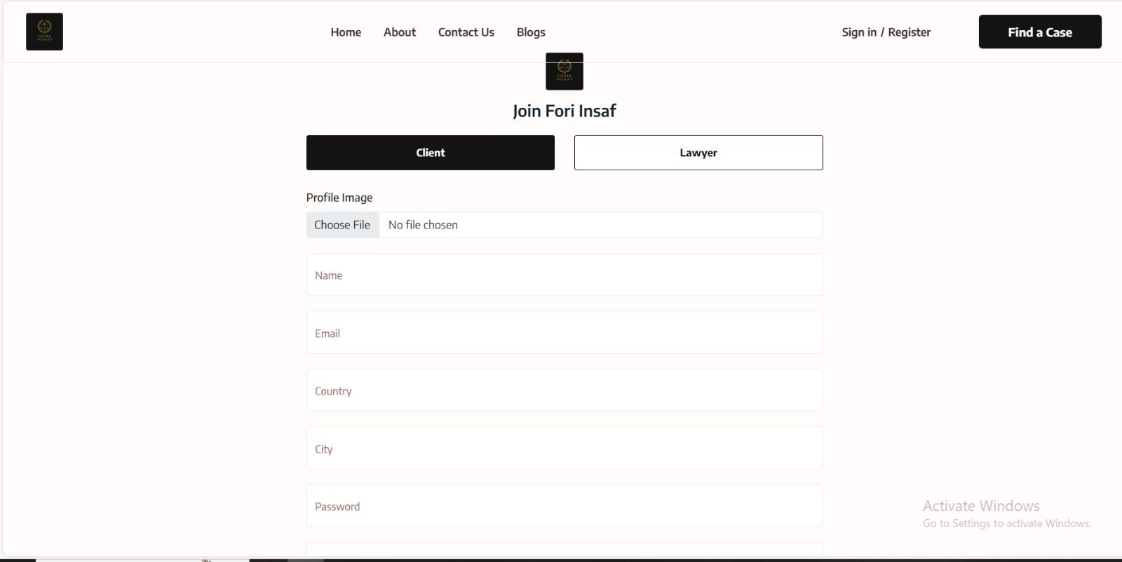

**Project Details**

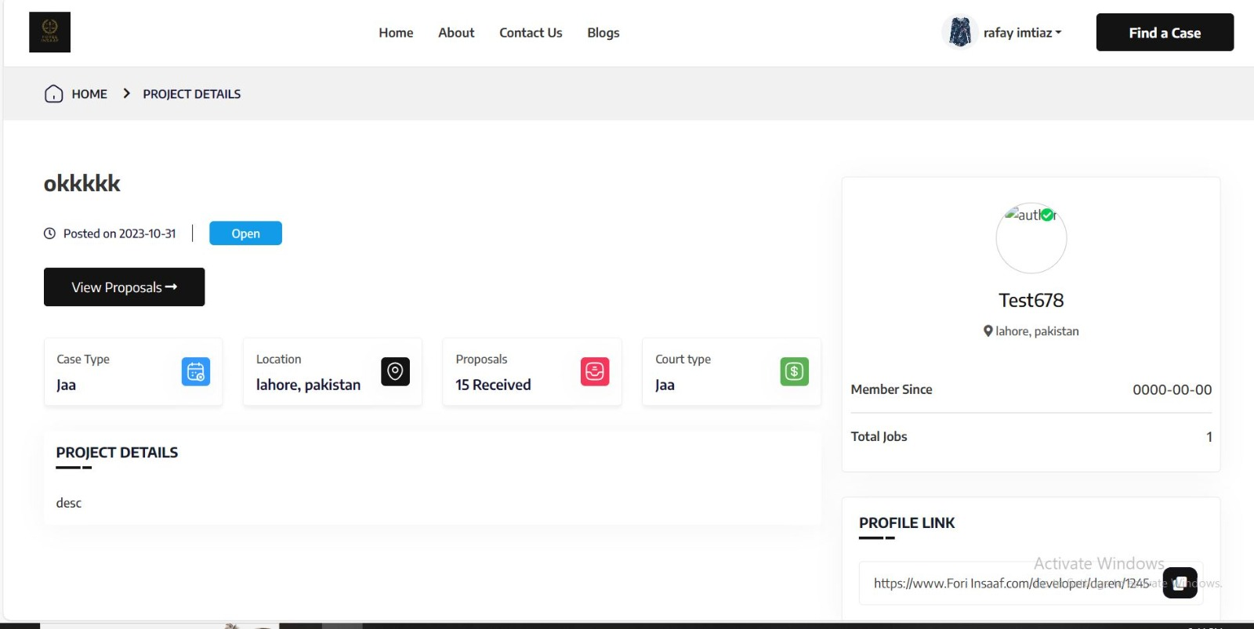

**Blog Page**

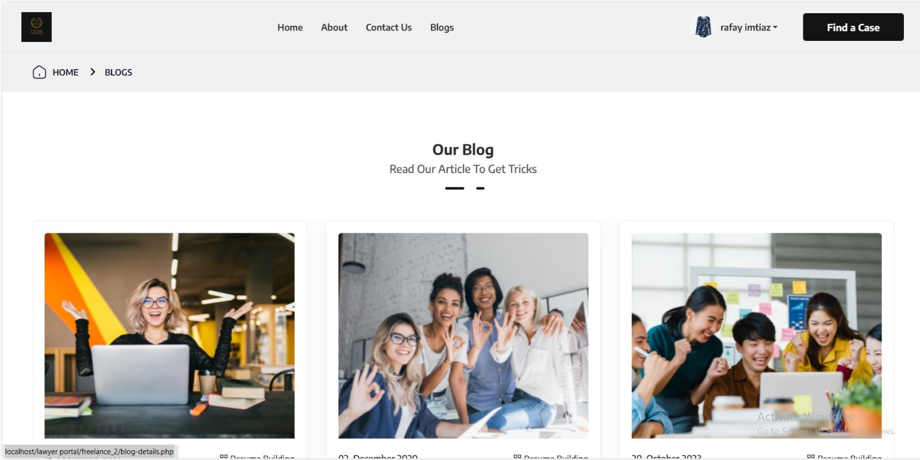

**Post a case**

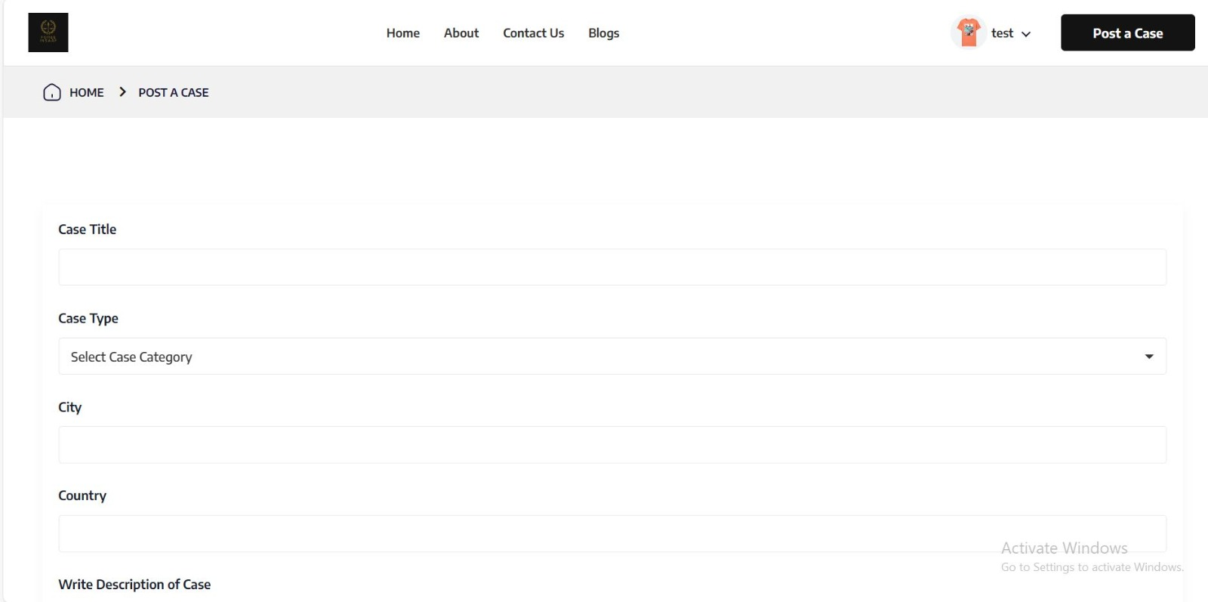

**Find a case**

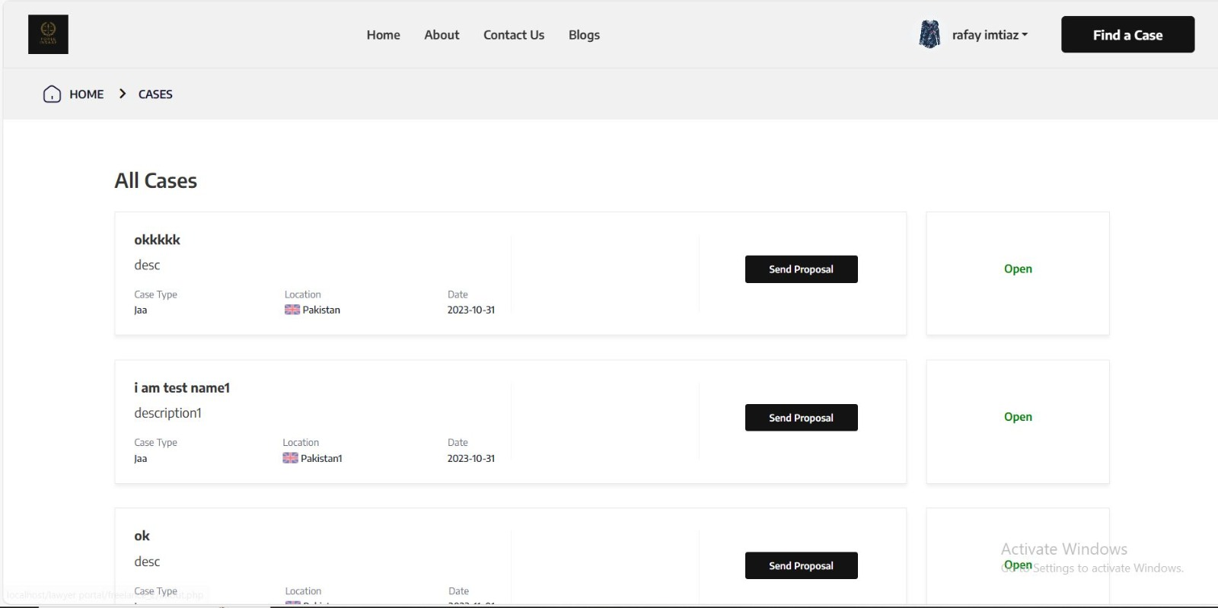

**Popular lawyer**

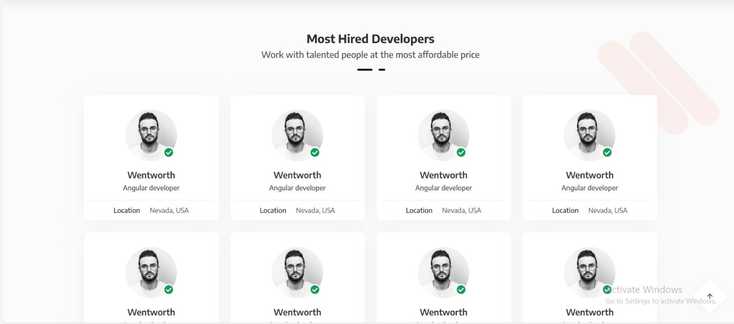

**5.0 Reuse and relationships to other products**

Emphasis is placed on the strategic reuse of key components to optimize efficiency and promote scalability. The platform adheres to industry standards, allowing for potential integration with complementary legal tools and databases. By incorporating modular design principles, future enhancements or feature additions can be seamlessly integrated without disrupting existing functionalities. This approach ensures that "Foree Insaf" remains adaptable to evolving legal technology landscapes, fostering compatibility with emerging tools and services within the legal industry. The platform's design philosophy encourages a harmonious relationship with external legal resources, enhancing its overall utility and longevity.

**6.0 Design decisions and tradeoffs**

Design decisions and tradeoffs

The design decisions for "Foree Insaf" prioritize a user-centric interface, streamlined navigation, and robust security measures. The platform adopts a responsive web design, ensuring accessibility across various devices. To balance performance and complexity, a modular architecture is employed, enabling scalability without compromising efficiency. Tradeoffs include careful consideration of feature prioritization to maintain a user-friendly experience and avoid information overload. The choice of technologies, such as PHP for backend development and MySQL for database management, is a deliberate decision for stability and compatibility. These design decisions aim to strike a harmonious balance between functionality, performance, and user satisfaction.

Appendix: Analysis Models

Class Diagram:

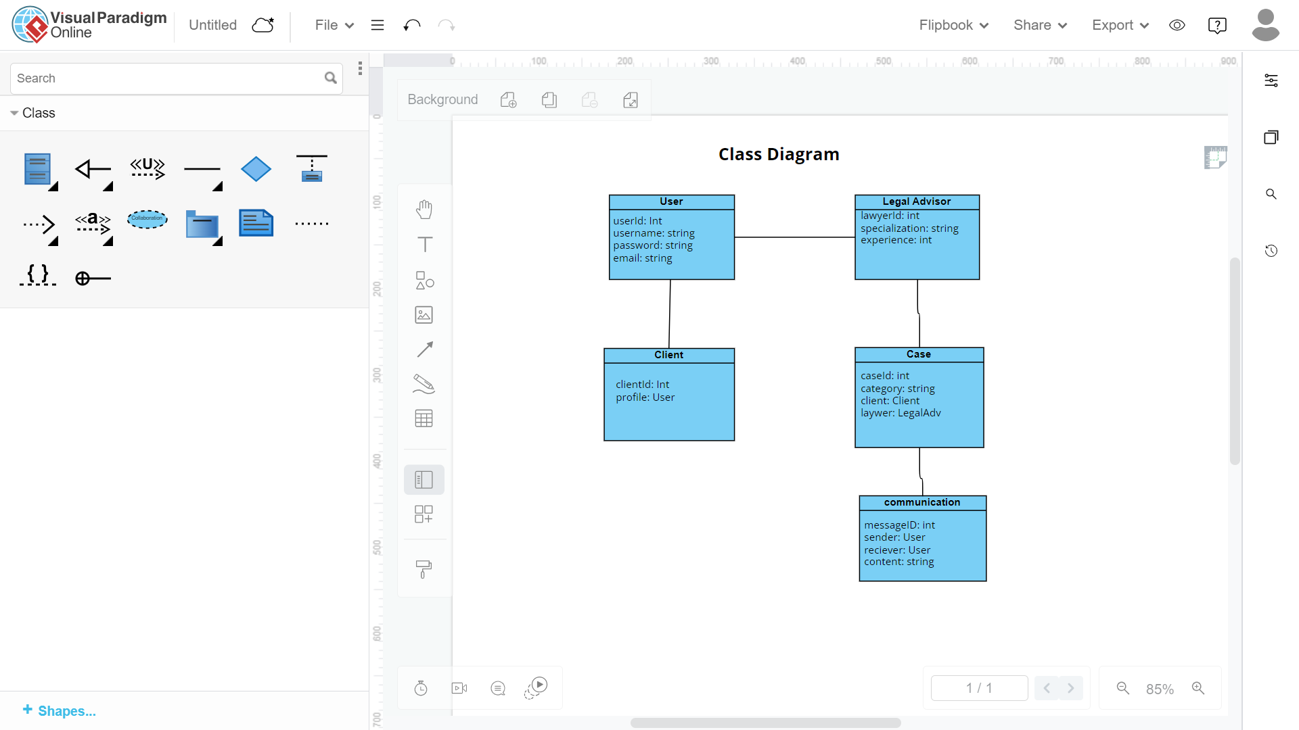

Use Case Diagram:

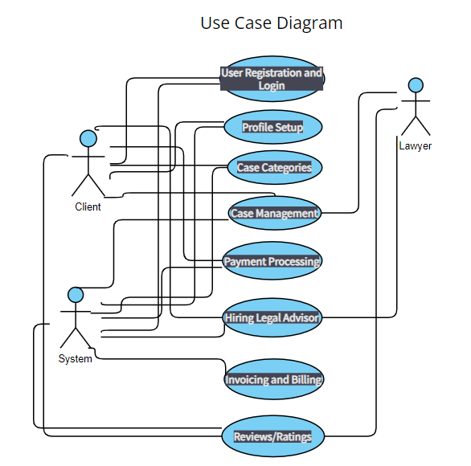

Sequence Diagram:

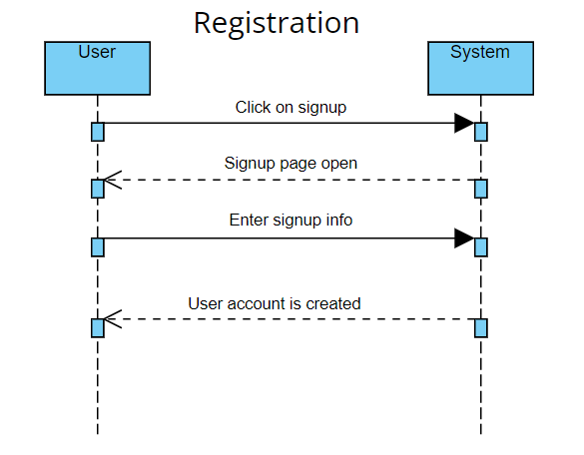

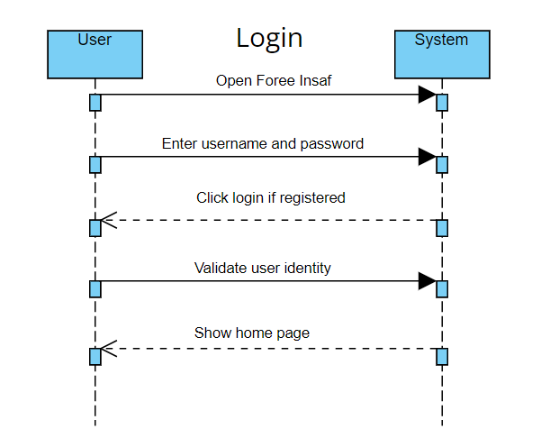

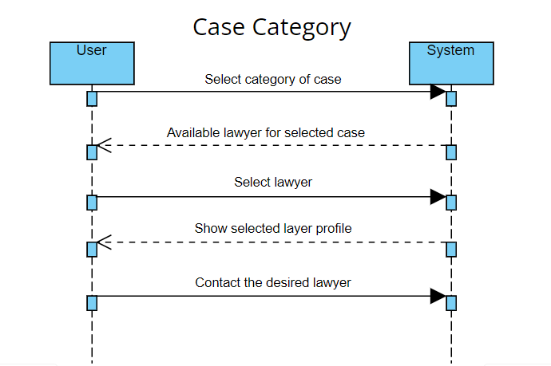

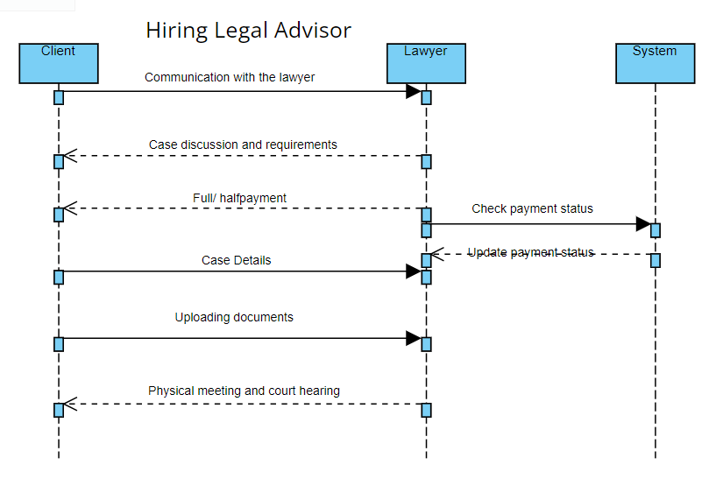

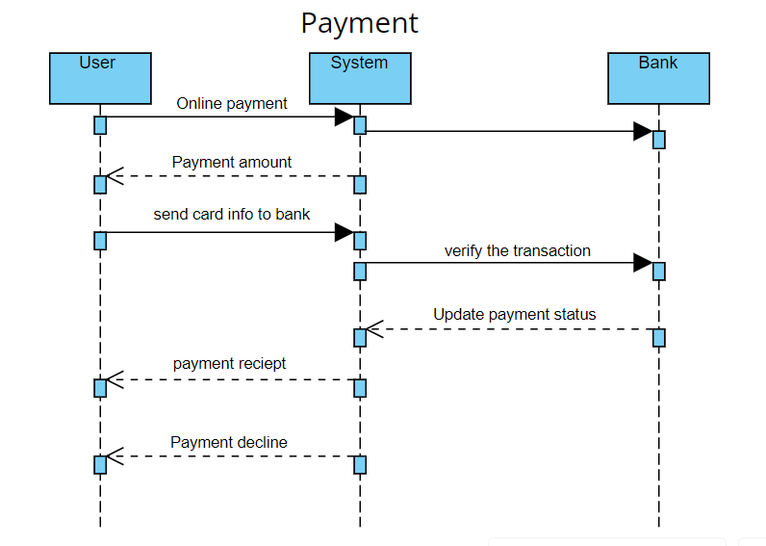

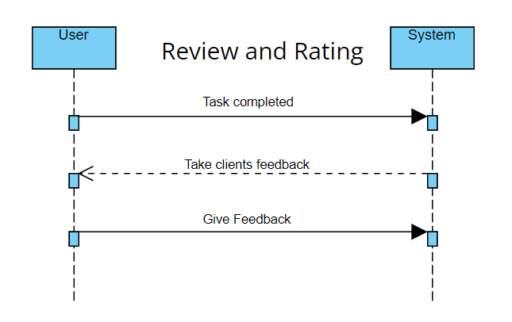

ERD Diagram:

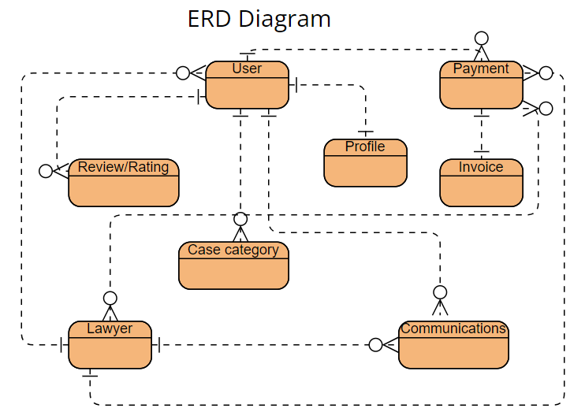

Activity Diagram:

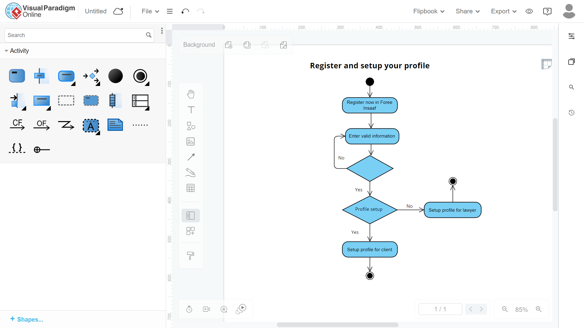

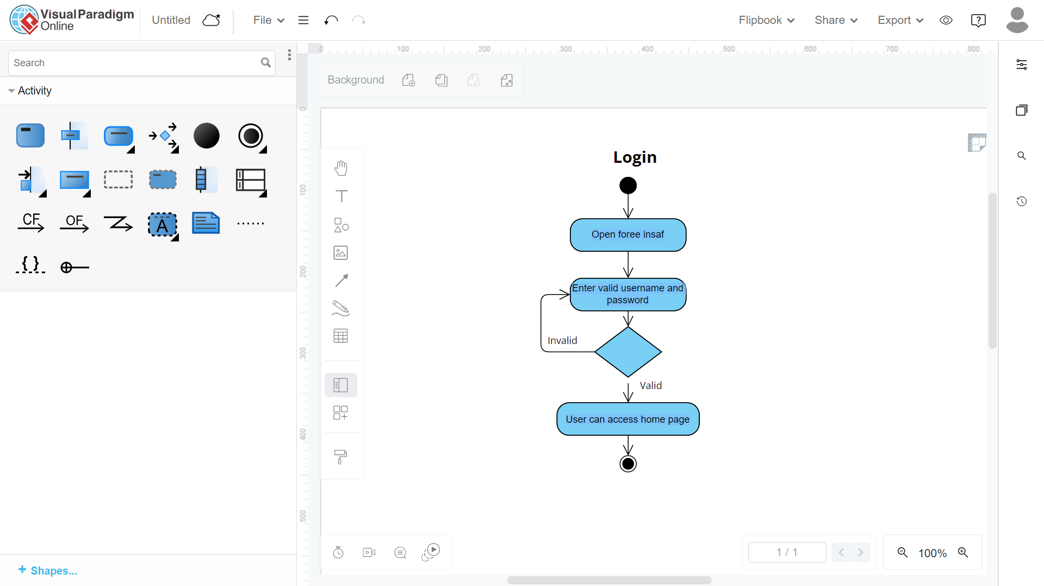

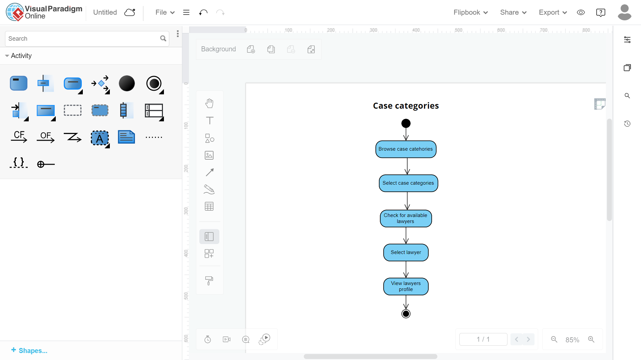

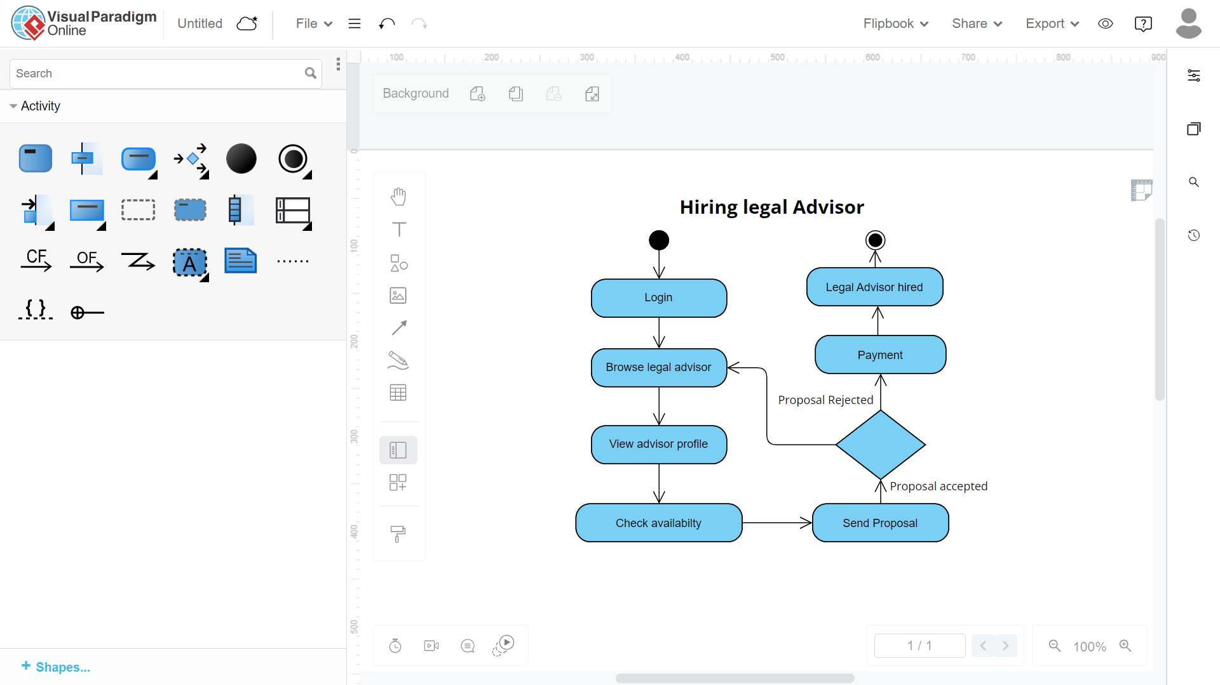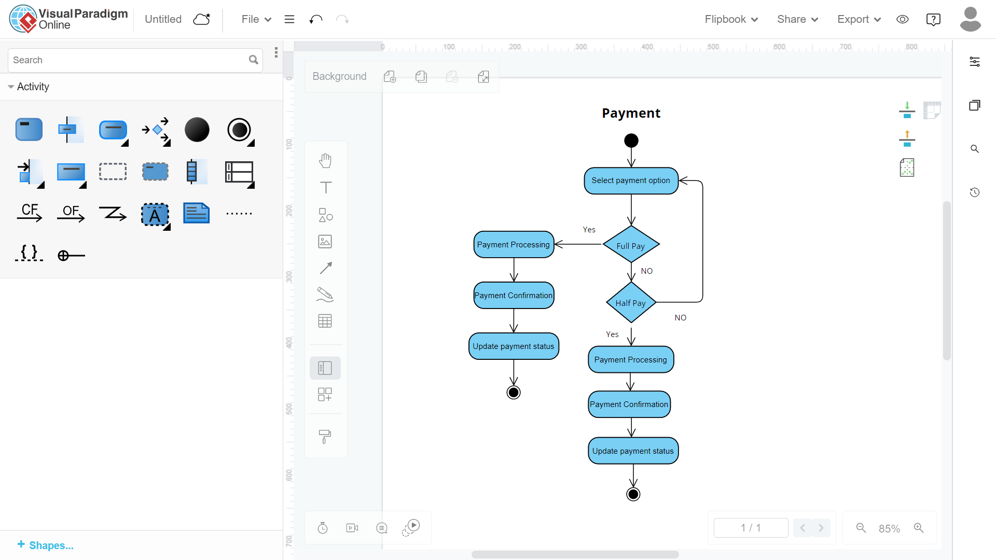

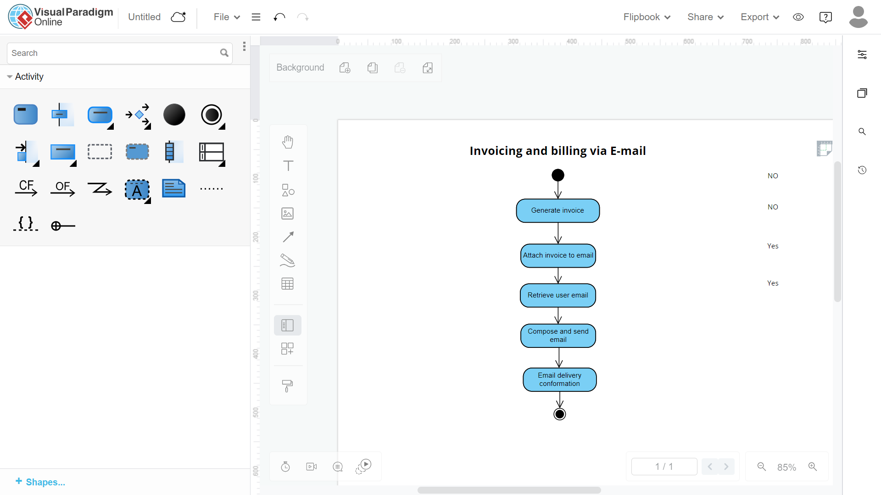

Object Diagram:

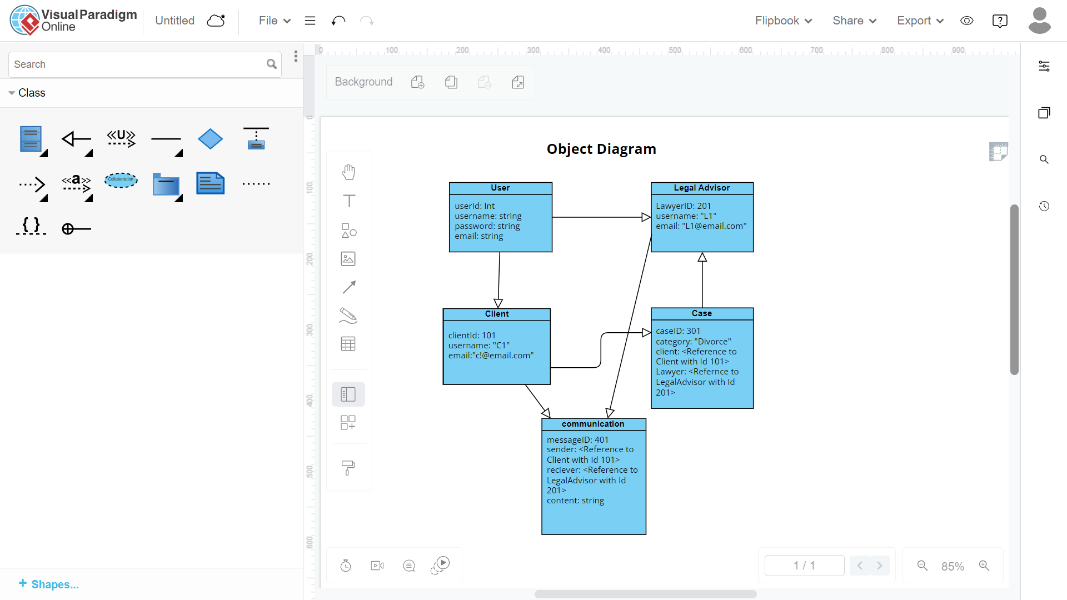

Deployment Diagram:

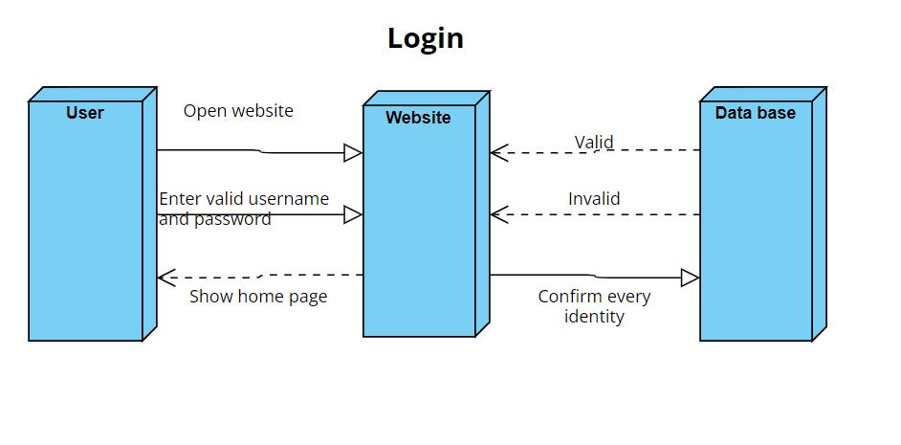

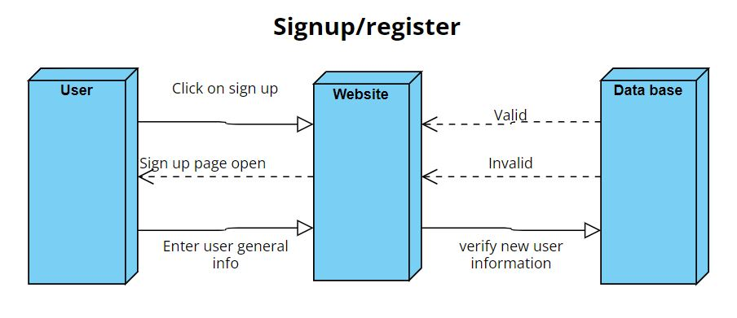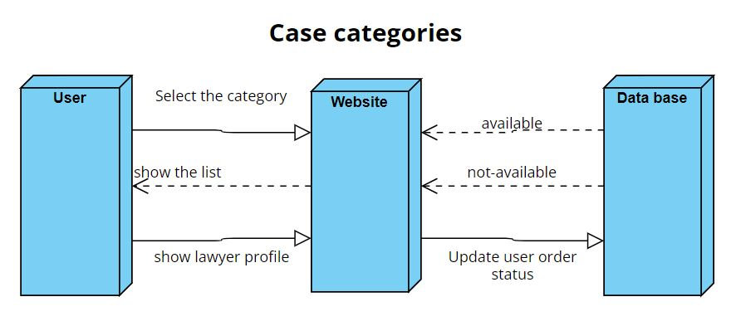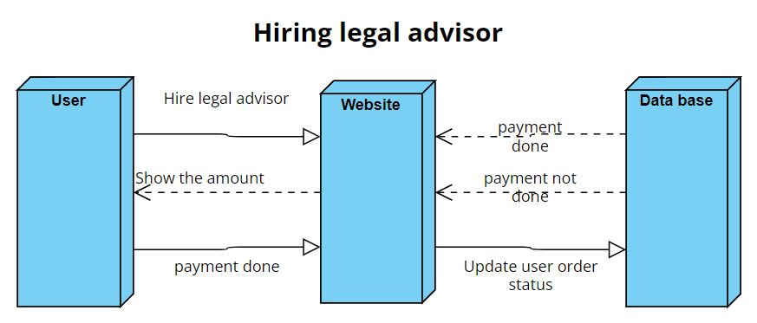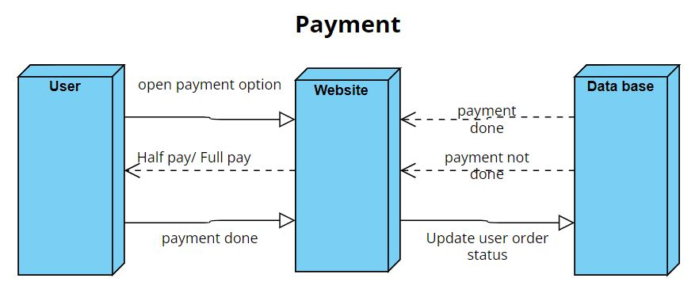

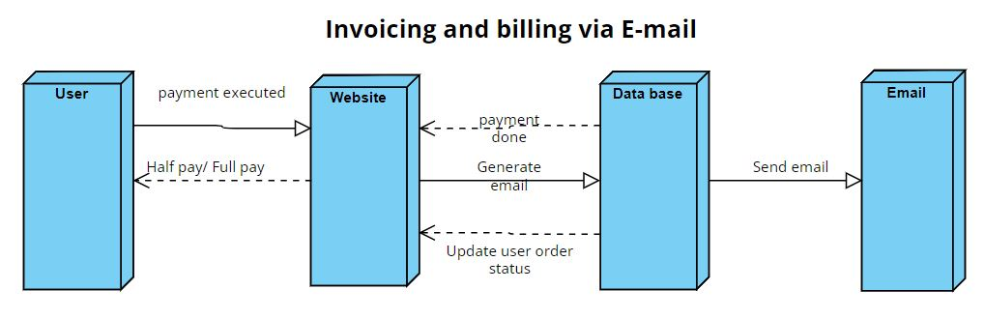

Component Diagram:

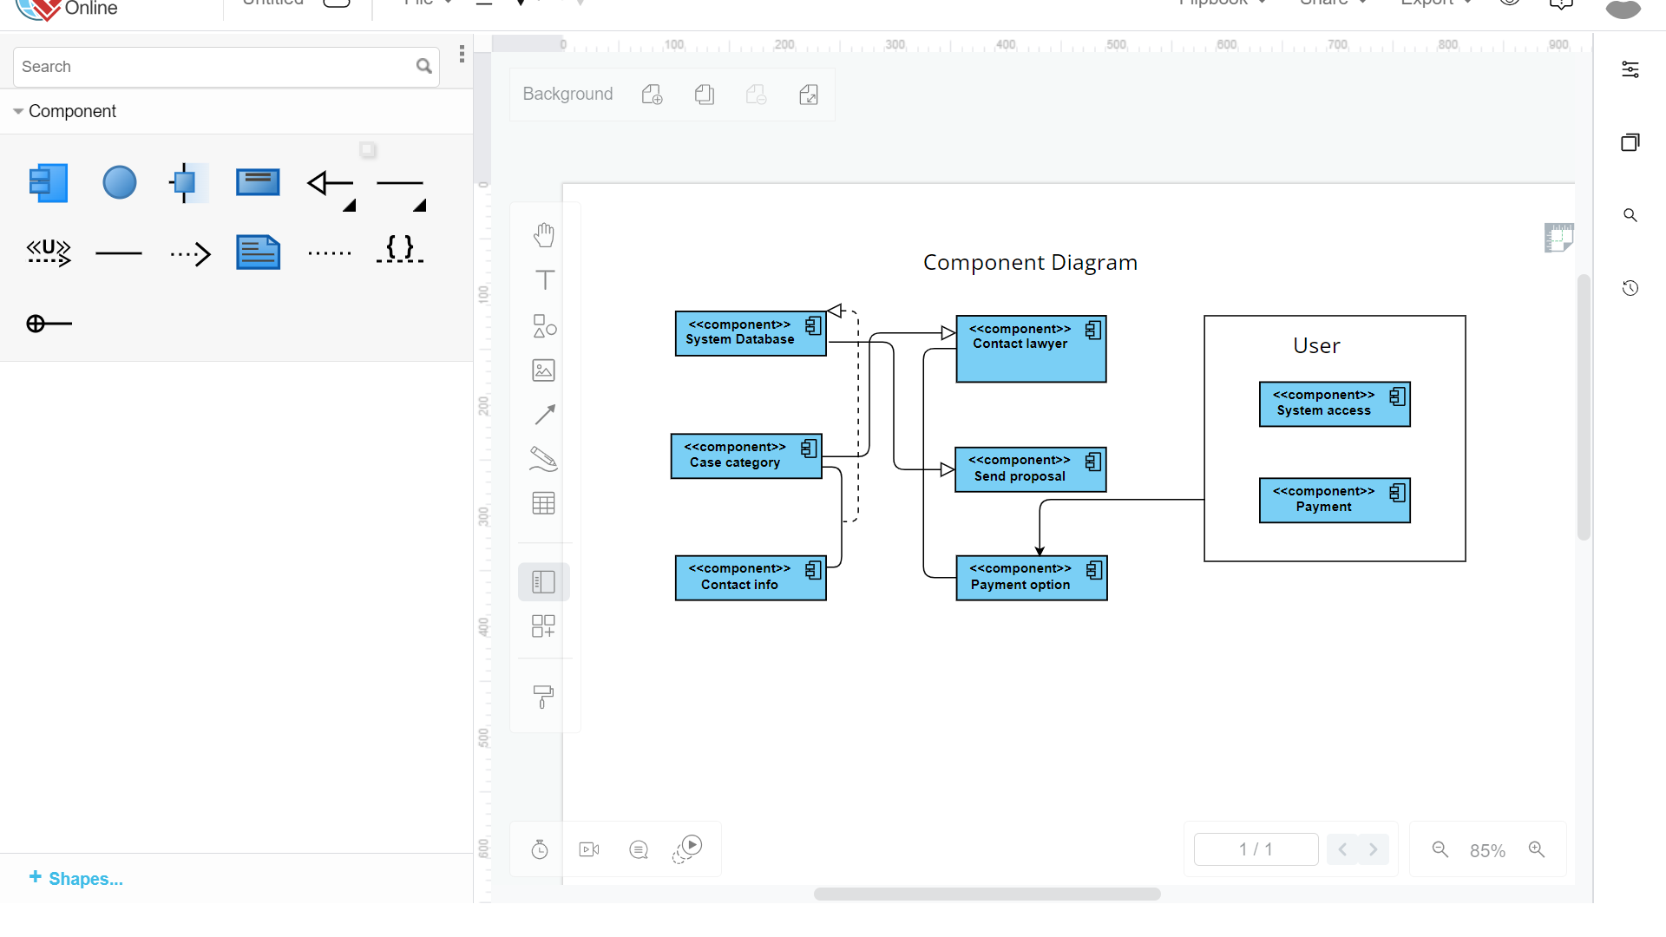

User Manual

1.

* 1. **General information**  
     Foree Insaf is a revolutionary online platform designed to connect clients with legal professionals efficiently. The system focuses on streamlining the legal service engagement process by providing clients with immediate access to a diverse range of lawyers, ensuring quick and informed decision-making. With a centralized digital system, lawyers can manage cases more effectively, fostering collaboration and organization. The platform enhances transparency through comprehensive legal profiles, reviews, and real-time communication. By addressing issues like difficulty in finding specialized lawyers and inefficient communication, Foree Insaf aims to transform the legal service landscape, providing users with accurate representation, streamlined processes, and improved outcomes.
  2. **Platforms**

the application is a website and that be accessed through the local host address on web browsers

* 1. **Acronyms and abbreviations**
  2. **System functions and configuration**

User Registration and Authentication:

Users register on the platform, providing necessary details for authentication.

Profile Setup:

Lawyers create comprehensive profiles, specifying practice areas and qualifications.

Case Management:

Lawyers browse and submit proposals for job listings matching their expertise.

Communication:

Clients and lawyers communicate through the Real-Time Interaction Messaging System.

Project Collaboration:

Lawyers collaborate on projects, providing updates through the messaging system.

Payment Integration:

Secure payment gateway integration for hassle-free financial transactions.

Feedback and Ratings:

Clients leave reviews and ratings, contributing to the reputation of lawyers and the platform.

Billing System:

Lawyers can generate invoices for their services, and clients receive platform-generated bills.

Exit and Feedback:

Both parties have the option to leave feedback after project completion.

the application is a website and that be accessed through the local host address on web browsers

2.

* 1. **Sytem summary**  
     Foree Insaaf Legal Platform (FILP) serves as a dynamic online hub facilitating the connection between clients and legal professionals. The platform prioritizes user-friendly interfaces, streamlined access, and secure communication channels. Lawyers create detailed profiles, submit proposals for relevant job listings, and engage in real-time communication with clients. The platform integrates a secure payment gateway for financial transactions and encourages transparent feedback through a robust rating system. FILP aims to enhance legal service accessibility, transparency, and efficiency, bridging the gap between clients and legal experts.

**HOME**



**Login page**



**Signup page**



**Project Details**



**Blog Page**



**Post a case**



**Find a case**



**Popular lawyer**

